Mini project-3

1.Create a MySQL table called playlists to store Spotify-style music playlists, with columns: playlist_id (primary key), user_id (foreign key), name (varchar), and created_at (datetime). Write the CREATE TABLE statement.
Ans).
CREATE TABLE playlists (
playlist_id INT AUTO_INCREMENT PRIMARY KEY,
user_id INT NOT NULL,
name VARCHAR(100),
created_at DATETIME
);
Output:
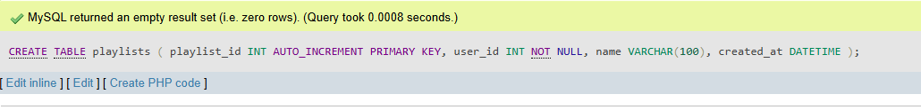
2).Insert three sample records into the playlists table: one for a user with a 'Workout Mix', one with a 'Chill Vibes', and one with a 'Top Hits' playlist. Use realistic data for each field.
Ans).INSERT INTO playlists(user_id,name,created_at) VALUES
(1,'Workout Mix','2026-07-01 10:00:00'),
(1,'Chill Vibes','2026-07-05 18:30:00'),
(2,'Top Hits','2026-07-10 09:15:00');
SELECT * FROM playlists;
Output:-
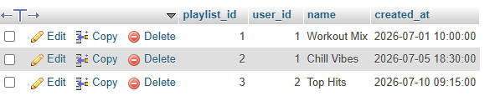
3.Write an SQL UPDATE statement to rename the 'Chill Vibes' playlist to 'Evening Chill' for a specific user_id.
Ans)UPDATE playlists SET name='Evening Chill' WHERE user_id=1 AND name='Chill Vibes';
SELECT * FROM playlists;
Output:-
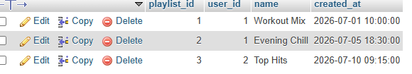
4).Write a DELETE statement to remove a playlist named 'Workout Mix' for a given user_id from the playlists table.<br><br><em><strong>Hint:</strong> Make sure your WHERE clause targets only the intended row.</em>
Ans).DELETE FROM playlists WHERE user_id=1 AND name='Workout Mix';
SELECT * FROM playlists;
Output:-

5).Create a stored procedure named GetMonthlyPlaylistCount that takes a user_id and a month (as an integer) as input, and returns the total number of playlists the user created in that month.<br><br><em><strong>Hint:</strong> Use the MONTH() function in your WHERE clause.</em>
Ans)CREATE PROCEDURE GetMonthlyPlaylistCount(IN p_user_id INT, IN p_month INT)
BEGIN
SELECT COUNT(*) AS TotalPlaylists
FROM playlists
WHERE user_id=p_user_id
AND MONTH(created_at)=p_month;
END $$
DELIMITER ;
CALL GetMonthlyPlaylistCount(1,7);
Output:-
TotalPlaylists
1

